1. INTRODUCTION

  - INTRODUCTION OF THE PROJECT
The GCC compiler compiles C code to create a binary file. This file is capable of running on a single processor only. Advances in the technology of microprocessors have now created up to 12 cores commercially! Presently written C code can only utilize one of the many processors available in the system. On the other hand, development of parallel versions of the existing software puts a huge burden on the programmer. For optimum utilization of multi-processor architecture following are required -
- Mastering a complicated parallel language
- Understanding intricate low level details of your system
- Identifying critical sections and handling them.
- Serialization.
- Inter-processor communication.
Parallel C is a software that can perform all the above functions on any given C code without any additional burden on the programmer! It is coded in GNU C and it uses the extensive features of the OpenMP libraries. An input serial code is converted into a multi-threaded, memory shared model with the help of optimum job allocation algorithms and OpenMP constructs. A load sharing system is created.
- A serial C code is taken as input.
- Hotspots and Bottlenecks are identified in the code (Estimation Phase).
- Critical sections are identified. Nature of variables within each hotspot is analyzed. Variables that have to be made private to a thread are separated from those that need to be shared among the threads. (Analyzing Phase)
- Appropriate constructs based on inputs from the Analyzing phase are added to parallelize the code (Splitting Phase)
- A parallel version of the given input program is obtained!

For an N processor architecture, speeds up to N times have been obtained when tested with appropriate samples!
The Program relies heavily on the features of the OpenMP libraries and its multi-threaded, shared model architecture.
OpenMP
OpenMP (Open Multi-Processing) is an application programming interface (API) that supports multi-platform shared memory multiprocessing programming in C, C++, and Fortran on many architectures, including Unix and Microsoft Windows platforms. It consists of a set of compiler directives, library routines, and environment variables that influence run-time behavior.
Jointly defined by a group of major computer hardware and software vendors, OpenMP is a portable, scalable model that gives programmers a simple and flexible interface for developing parallel applications for platforms ranging from the desktop to the supercomputer.
An application built with the hybrid model of parallel programming can run on a computer cluster using both OpenMP and Message Passing Interface (MPI), or more transparently through the use of OpenMP extensions for non-shared memory systems.

OpenMP is an Application Program Interface (API), jointly defined by a group of major computer hardware and software vendors. OpenMP provides a portable, scalable model for developers of shared memory parallel applications. The API supports C/C++ and Fortran on multiple architectures, including UNIX & Windows NT. This tutorial covers most of the major features of OpenMP, including its various constructs and directives for specifying parallel regions, work sharing, synchronization and data environment. Runtime library functions and environment variables are also covered.

OpenMP is an implementation of multithreading, a method of parallelization whereby the master "thread" (a series of instructions executed consecutively) "forks" a specified number of slave "threads" and a task is divided among them. The threads then run concurrently, with the runtime environment allocating threads to different processors.

The section of code that is meant to run in parallel is marked accordingly, with a preprocessor directive that will cause the threads to form before the section is executed. Each thread has an "id" attached to it which can be obtained using a function (called omp_get_thread_num()). The thread id is an integer, and the master thread has an id of "0". After the execution of the parallelized code, the threads "join" back into the master thread, which continues onward to the end of the program.

By default, each thread executes the parallelized section of code independently. "Work-sharing constructs" can be used to divide a task among the threads so that each thread executes its allocated part of the code. Both task parallelism and data parallelism can be achieved using OpenMP in this way.

The runtime environment allocates threads to processors depending on usage, machine load and other factors. The number of threads can be assigned by the runtime environment based on environment variables or in code using functions. The OpenMP functions are included in a header file labeled "omp.h" in C/C++.

  - SCOPE OF THE PROJECT

Due to the advances in the field of microprocessor technology, Processors with up to 12 cores on a single chip have been created commercially. There is a huge demand for software that fully utilizes these cores to give optimum performance. Writing code for existing software puts additional burden on the programmer. Mastering a parallel language, learning the detailed architecture of the system, critical section identification, serialization etc have all to be focused on besides programming logic.
Parallel C forms a breakthrough in the field of producing parallel efficient code from existing serial codes. All features of inter-processor communication, synchronization, mutual exclusion etc have been incorporated in the system. All implementation details have been abstracted from the user. All that is required is the input of a serial code to obtain efficient parallel code
For programmers with dual core or quad core CPUs, code I generated that uses all the processors in a load sharing manner. No processor is left idle. It reduces the execution time but efficiently utilizing the system resources. That is in a dual core system it can use the processing power of both the cores to get the output faster.
Thus the processing power of almost any program can be drastically improved by the application of this software!

  - ADVANTAGES OF THE PROPOSED SYSTEM
Parallel C shares the load between processors using a Multi-threaded and shared memory model!
- No processor is left idle.
- Increased efficiency since optimal job allocation algorithms followed.
- Less resource wastage and quick execution time.
- Identification of Hotspots and Bottlenecks in the program for further efficiency improvement by programmer.
- Future proof.
- Simple: need not deal with message passing as MPI does
- Data layout and decomposition is handled automatically by directives.
- Incremental parallelism: can work on one portion of the program at one time, no dramatic change to code is needed.
- Unified code for both serial and parallel applications: OpenMP constructs are treated as comments when sequential compilers are used.
- Original (serial) code statements need not, in general, be modified when parallelized with OpenMP. This reduces the chance of inadvertently introducing bugs.
- Portability
- Standardized .

  - DISADVANTAGES OF THE PROPOSED SYSTEM
Our proposed system has the following disadvantages:-

- No performance improvement on single core CPUs.
• Requires a compiler that supports OpenMP.
• Scalability is limited by memory architecture.
• Reliable error handling is missing.

• Can't be used on GPU

2. LITERARY SURVEY

2.1. OpenMP Programming Model
Shared Memory, Thread Based Parallelism:
- OpenMP is based upon the existence of multiple threads in the shared memory programming paradigm. A shared memory process consists of multiple threads.
Explicit Parallelism:
- OpenMP is an explicit (not automatic) programming model, offering the programmer full control over parallelization.
Fork - Join Model:
- OpenMP uses the fork-join model of parallel execution:
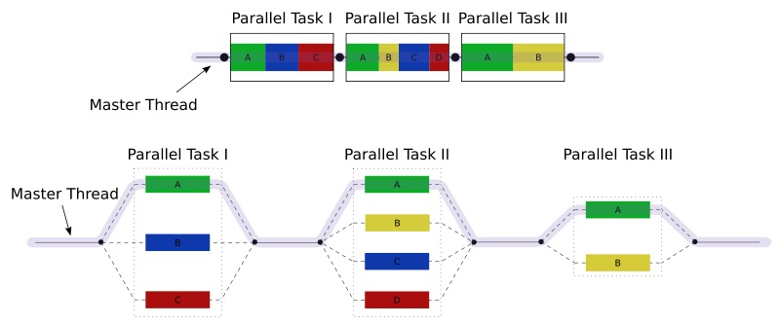
- All OpenMP programs begin as a single process: the master thread. The master thread executes sequentially until the first parallel region construct is encountered.
- FORK: the master thread then creates a team of parallel threads
- The statements in the program that are enclosed by the parallel region construct are then executed in parallel among the various team threads
- JOIN: When the team threads complete the statements in the parallel region construct, they synchronize and terminate, leaving only the master thread
Compiler Directive Based:
- Most OpenMP parallelism is specified through the use of compiler directives which are imbedded in C/C++ or Fortran source code.
Nested Parallelism Support:
- The API provides for the placement of parallel constructs inside of other parallel constructs.
- Implementations may or may not support this feature.
Dynamic Threads:
- The API provides for dynamically altering the number of threads which may used to execute different parallel regions.
- Implementations may or may not support this feature.
I/O:
- OpenMP specifies nothing about parallel I/O. This is particularly important if multiple threads attempt to write/read from the same file.
- If every thread conducts I/O to a different file, the issues are not as significant.
- It is entirely up to the programmer to insure that I/O is conducted correctly within the context of a multi-threaded program.
Memory Model: FLUSH Often?
- OpenMP provides a "relaxed-consistency" and "temporary" view of thread memory (in their words). In other words, threads can "cache" their data and are not required to maintain exact consistency with real memory all of the time.
- When it is critical that all threads view a shared variable identically, the programmer is responsible for insuring that the variable is FLUSHed by all threads as needed.

2.2 The core elements

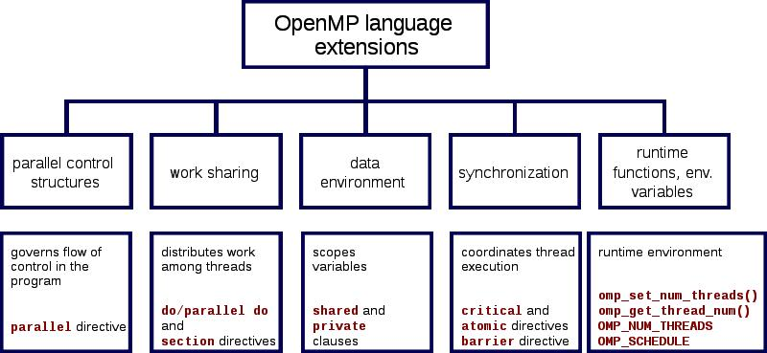

The core elements of OpenMP are the constructs for thread creation, workload distribution (work sharing), data-environment management, thread synchronization, user-level runtime routines and environment variables.

Thread creation
omp parallel. It is used to fork additional threads to carry out the work enclosed in the construct in parallel. The original process will be denoted as master thread with thread ID 0.
Example: Display "Hello, world" using multiple threads.
int main(int argc, char *argv[])
{
#pragma omp parallel
printf("Hello, world.\n");
return 0;
}

Work-sharing constructs
used to specify how to assign independent work to one or all of the threads.
omp for or omp do: used to split up loop iterations among the threads, also called loop constructs.
sections: assigning consecutive but independent code blocks to different threads
single: specifying a code block that is executed by only one thread, a barrier is implied in the end
master: similar to single, but the code block will be executed by the master thread only and no barrier implied in the end.
Example: initialize the value of a large array in parallel, using each thread to do a portion of the work
int main(int argc, char *argv[]) {
const int N = 100000;
int i, a[N];
#pragma omp parallel for
for (i = 0; i < N; i++)
a[i] = 2 * i;
return 0;
}

OpenMP clauses
Since OpenMP is a shared memory programming model, most variables in OpenMP code are visible to all threads by default. But sometimes private variables are necessary to avoid race conditions and there is a need to pass values between the sequential part and the parallel region (the code block executed in parallel), so data environment management is introduced as data sharing attribute clauses by appending them to the OpenMP directive. The different types of clauses are

Data sharing attribute clauses
shared: the data within a parallel region is shared, which means visible and accessible by all threads simultaneously. By default, all variables in the work sharing region are shared except the loop iteration counter.
private: the data within a parallel region is private to each thread, which means each thread will have a local copy and use it as a temporary variable. A private variable is not initialized and the value is not maintained for use outside the parallel region. By default, the loop iteration counters in the OpenMP loop constructs are private.
default: allows the programmer to state that the default data scoping within a parallel region will be either shared, or none for C/C++, or shared, firstprivate, private, or none for Fortran. The none option forces the programmer to declare each variable in the parallel region using the data sharing attribute clauses.
firstprivate: like private except initialized to original value.
lastprivate: like private except original value is updated after construct.
reduction: a safe way of joining work from all threads after construct.

Synchronization clauses
critical section: the enclosed code block will be executed by only one thread at a time, and not simultaneously executed by multiple threads. It is often used to protect shared data from race conditions.
atomic: similar to critical section, but advise the compiler to use special hardware instructions for better performance. Compilers may choose to ignore this suggestion from users and use critical section instead.
ordered: the structured block is executed in the order in which iterations would be executed in a sequential loop
barrier: each thread waits until all of the other threads of a team have reached this point. A work-sharing construct has an implicit barrier synchronization at the end.
nowait: specifies that threads completing assigned work can proceed without waiting for all threads in the team to finish. In the absence of this clause, threads encounter a barrier synchronization at the end of the work sharing construct.
Scheduling clauses
schedule(type, chunk): This is useful if the work sharing construct is a do-loop or for-loop. The iteration(s) in the work sharing construct are assigned to threads according to the scheduling method defined by this clause. The three types of scheduling are:
static: Here, all the threads are allocated iterations before they execute the loop iterations. The iterations are divided among threads equally by default. However, specifying an integer for the parameter "chunk" will allocate "chunk" number of contiguous iterations to a particular thread.
dynamic: Here, some of the iterations are allocated to a smaller number of threads. Once a particular thread finishes its allocated iteration, it returns to get another one from the iterations that are left. The parameter "chunk" defines the number of contiguous iterations that are allocated to a thread at a time.
guided: A large chunk of contiguous iterations are allocated to each thread dynamically (as above). The chunk size decreases exponentially with each successive allocation to a minimum size specified in the parameter "chunk"
IF control
if: This will cause the threads to parallelize the task only if a condition is met. Otherwise the code block executes serially.

Initialization
firstprivate: the data is private to each thread, but initialized using the value of the variable using the same name from the master thread.
lastprivate: the data is private to each thread. The value of this private data will be copied to a global variable using the same name outside the parallel region if current iteration is the last iteration in the parallelized loop. A variable can be both firstprivate and lastprivate.
threadprivate: The data is a global data, but it is private in each parallel region during the runtime. The difference between threadprivate and private is the global scope associated with threadprivate and the preserved value across parallel regions.

Data copying
copyin: similar to firstprivate for private variables, threadprivate variables are not initialized, unless using copyin to pass the value from the corresponding global variables. No copyout is needed because the value of a threadprivate variable is maintained throughout the execution of the whole program.
copyprivate: used with single to support the copying of data values from private objects on one thread (the single thread) to the corresponding objects on other threads in the team.
Reduction
reduction(operator | intrinsic : list): the variable has a local copy in each thread, but the values of the local copies will be summarized (reduced) into a global shared variable. This is very useful if a particular operation (specified in "operator" for this particular clause) on a datatype that runs iteratively so that its value at a particular iteration depends on its value at a previous iteration. Basically, the steps that lead up to the operational increment are parallelized, but the threads gather up and wait before updating the datatype, then increments the datatype in order so as to avoid racing condition. This would be required in parallelizing Numerical Integration of functions and Differential Equations, as a common example.

Others
flush: The value of this variable is restored from the register to the memory for using this value outside of a parallel part
master: Executed only by the master thread (the thread which forked off all the others during the execution of the OpenMP directive). No implicit barrier; other team members (threads) not required to reach.
User-level runtime routines
Used to modify/check the number of threads, detect if the execution context is in a parallel region, how many processors in current system, set/unset locks, timing functions, etc.
Environment variables
A method to alter the execution features of OpenMP applications. Used to control loop iterations scheduling, default number of threads, etc. For example OMP_NUM_THREADS is used to specify number of threads for an application.

Implementations
OpenMP has been implemented in many commercial compilers. For instance, Visual C++ 2005, 2008 and 2010 support it (in their Professional, Team System, Premium and Ultimate editions, as well as Intel Parallel Studio for various processors. Sun Studio compilers and tools support the latest OpenMP specifications with productivity enhancements for Solaris OS (UltraSPARC and x86/x64) and Linux platforms. The Fortran, C and C++ compilers from The Portland Group also support OpenMP 2.5. GCC has also supported OpenMP since version 4.2.
A few compilers have early implementation for OpenMP 3.0, including
- GCC 4.3.1
- Nanos compiler
- Intel Fortran and C/C++ versions 11.0 and 11.1 Compilers, Intel C/C++ and Fortran Composer XE 2011 and Intel Parallel Studio.
- IBM XL C/C++ Compiler
Sun Studio 12 update 1 has full implementation of OpenMP 3.0

3. HARDWARE AND SOFTWARE SPECIFICATIONS

3.1 SOFTWARE SPECIFICATION

Following are the basic software specifications for the project:-
- Platform – C (with Openmp library).
- Operating System – Ubuntu 10.10

3.2 HARDWARE SPECIFICATION

Following are the basic hardware specifications for the project:-
- Dual core or Quad core CPU.
- 512 MB RAM.
- 20 GB HARD DISK.

4. SYSTEM ANALYSIS AND DESIGN

4.1 EXISTING SYSTEM
The existing GCC compiler compiles C code to create a binary file. This file is capable of running on a single processor only. Advances in the technology of microprocessors have now created up to 12 cores commercially! Presently written C code can only utilize one of the many processors available in the system. On the other hand, development of parallel versions of the existing software puts a huge burden on the programmer.
Existing systems has the following drawbacks if executed serially:
- It uses only the power of a single core irrespective of the number of cores in the system.
- Very low resource utilization.
- Wastage of Processing Power.
- High Processing time.
- Overload on a single processor.
- System specs don’t alter performance!
For optimum utilization of multi-processor architecture following are required -
- Mastering a complicated parallel language
- Understanding intricate low level details of your system
- Identifying critical sections and handling them.
- Serialization.
- Inter-processor communication.

4.2 REQUIREMENT ANALYSIS

Parallel C aims to create a method that will covert any existing serial code to a parallel version with maximum abstraction of details from the user. Hence the following are the requirements that have to be met.

- Estimation of the Hotspots and Bottlenecks in a given code.
- Analysis of the identified parallelizable regions.
- Identification of variables private to every thread
- Identification of shared data variables.
- Detection of critical sections and their handling.
- Synchronization of various threads.
- Inter-process communication to efficiently share the load.
- Handle errors in a parallel architecture.
- Abstraction of details from the user.
- No additional burden on the user
- User friendly application

4.3 PROPOSED SYSTEM

Parallel C shares the load between processors using a Multi-threaded and shared memory model!
- A serial C code is taken as input.
- Hotspots and Bottlenecks are identified (Estimation Module)
- Critical sections, nature of variables etc are analyzed (Analyzing Module)
- Appropriate constructs are added to parallelize the code (Splitting Module)
- A parallel version of the given input program is obtained!

ADVANTAGES OF PROPOSED SYSTEM

- No processor is left idle.
- Increased efficiency since optimal job allocation algorithms followed.
- Less resource wastage and quick execution time.
- Identification of Hotspots and Bottlenecks in the program for further efficiency improvement by programmer.

4.4 MODULE DIVISION

For the optimal working and testing of the software, Parallel C has been divided into 3 main modules. It is a linear model of process transfer, described as follows

- A serial C code is taken as input.
- Hotspots and Bottlenecks are identified (Estimation Module)
- Critical sections, nature of variables etc are analyzed (Analyzing Module)
- Appropriate constructs are added to parallelize the code (Splitting Module)
- A parallel version of the given input program is obtained!

As mentioned, Parallel C has the following 3 modules :

- Estimation Module
- Analyzing Module
- Splitting Module

ESTIMATION MODULE

The Input C code is first sent to this module. The entire code is read by the software to identify regions that can be parallelized.

- This module focuses on identifying Hotspots in the code.
- These are regions where maximum computation occurs.
- Identifies regions that can be parallelized.
- The blocks of code where maximum computations occur are –
  - Loops
  - Recursions

ANALYZING MODULE

Each identified block by the previous module is analyzed for the following
- CRITICAL SECTIONS and other bottlenecks.
- Variables PRIVATE to every thread.
- Variables to be SHARED among the threads.
- Analysis to check whether region should be parallelized or not.

SPLITTING MODULE

The analyzed facts are used to select appropriate OpenMP constructs to help split the program.
Eg-
  - Loops : #pragma omp parallel for
  - Critical Section : #pragma omp critical
  - Private : #pragma omp parallel private(i,j,k)
  - Shared : #pragma omp parallel shared(x,y)

4.5 Activity Diagram
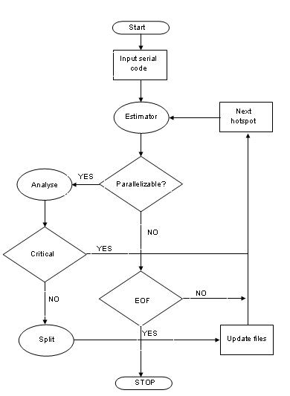

4.6 DFD
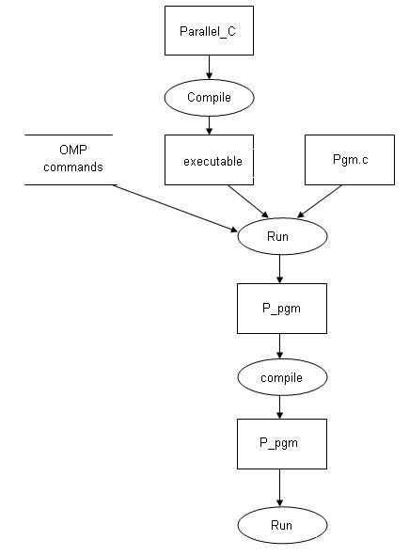

4.7 UML DIAGRAMS
Use case diagram

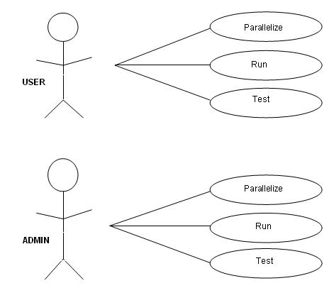

5. IMPLEMENTATION

The algorithm for the software is written as follows:

- A serial C code is taken as input.
- Constructs in the code that can be parallelized are identified. Constructs include loops, both nested and single.
- These identified blocks of parallelizable code are analysed for the following
  - Critical sections
  - Private variables
  - Shared variables
  - Analysis on non parallelizable blocks

- Based on the analysis of the blocks, appropriate constructs are added to parallelize the code. Following constructs are added as follows

  - Loops : #pragma omp parallel for
  - Critical Section : #pragma omp critical
  - Private : #pragma omp parallel private(i,j,k)
  - Shared : #pragma omp parallel shared(x,y)

  - The construct chosen is added into the parallel version of the give input file and updated.

  - If all such parallelizable blocks have been visited, end execution.

  - Else estimate the next parallelizable block and repeat steps from there.

6. TESTING STRATERGIES

UNIT TESTING
- Estimation Module
This module has been tested on a number of sample codes. Hotspots have been identified successfully .
- Analyzing Module
This module has been tested on a number of sample codes. Critical regions, Private and shared variables have been successfully identified .
- Splitting Module
This module has been tested on a number of sample codes. Identified critical regions, Private and shared variables etc have been used to select appropriate OpenMP constructs.

INTEGRATION TESTING
All three modules have been integrated and tested to create a prototype of Parallel C with limited functionality.

- Estimation Module
- Analyzing Module
- Splitting Module

SYSTEM TESTING

The software was tested on a Matrix Multiplication (2000x2000) to generate the following results on the given systems-

Serial execution : 110 secs

Parallel execution on-
Dual Core Processor : 61 secs
Quad Core Processor : 27 secs

7. RESULTS

The software was tested on a Matrix Multiplication (2000x2000) to generate the following results on the given systems-
- Serial execution : 110 secs
- Parallel execution on-
  - Dual Core Processor : 61 secs
  - Quad Core Processor : 27 secs

7.1 SCREEN SHOTS
On a dual core system :
1) Serial execution

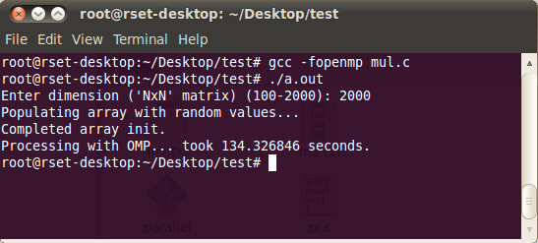
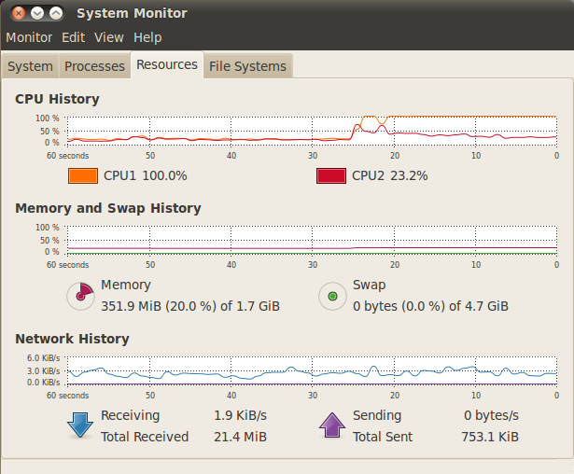

2) Parallel execution, after conversion with Parallel C

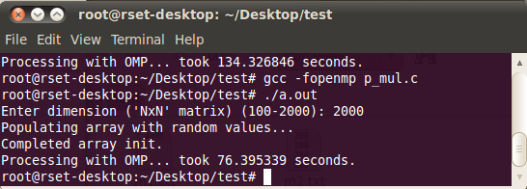
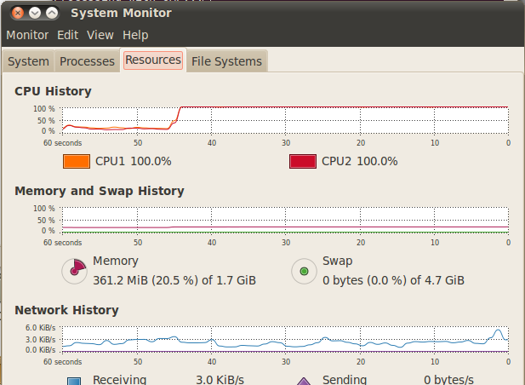

On a quad core system :
1)Serial execution

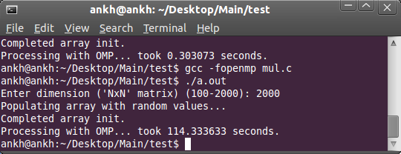

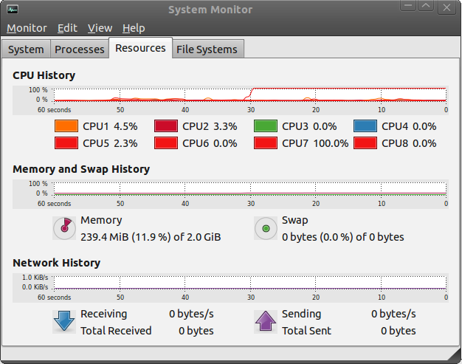

2) Parallel execution, after conversion with Parallel C

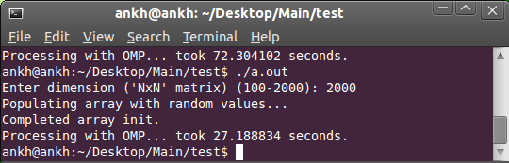

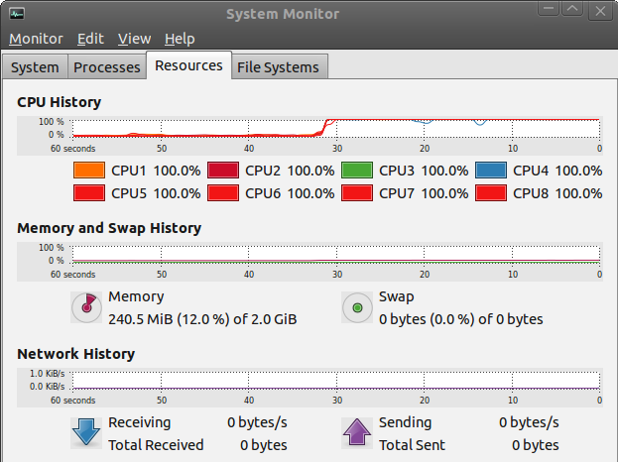

8. CONCLUSION
To program a parallel program, one has to
- Master a complicated parallel language
- Understand intricate low level details of the system
- Identify critical sections and handle them.
- Serialize code.
- Perform inter-process communication etc
Parallel C is a software that can perform all the above functions on any given C code with just the click of a button!

Computers were built to help man become lazy.
Parallel C is a yet another breakthrough in this venture!

9. FUTURE ENHANCEMENTS

Although Parallel C has helped convert any existing C code to a parallel version, a lot more can be done to further enhance its capabilities. Some of the features that we’ve identified are-

- Extend logic to handle parallelization of recursion.
- Improve inter-processor communications to communicate with remote systems as well.
- Incorporate MPI also in the architecture to create efficient cluster computation.

11. REFERENCES

- https://computing.llnl.gov/tutorials/openMP/

- Quinn Michael J, Parallel Programming in C with MPI and OpenMP McGraw-Hill Inc. 2004.
- R. Chandra, R. Menon, L. Dagum, D. Kohr, D. Maydan, J. McDonald, Parallel Programming in OpenMP. Morgan Kaufmann, 2000.

